**Raptor Flow Chart for the Rabbits Project**

Below is a flow diagram for the Rabbits project created in a tool called Raptor. 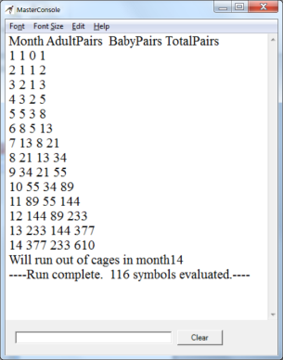This tool lets one create a flow diagram which is then executable by pressing the triangle button. The result of the run is shown in the mater console shown below.   
